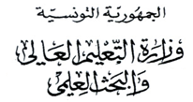
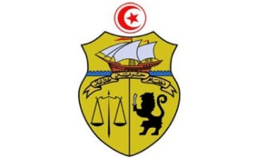
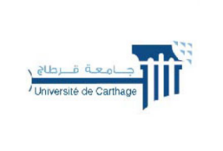

جامعة قرطاج
كلية العلوم الاقتصادية والتصرف بنابل

LISTE DES ETUDIANTS ORIENTES
2BIS
N | CIN / Passport | Nom | Prénom
1 | *****171 | Rhifi | Isra
2 | *****788 | Nader | Jebali
3 | *****608 | Chaouch | Hiba
4 | *****149 | cherif | mayssoun
5 | *****776 | jerbi | yassine
6 | *****692 | Ben Dhifallah | Med Yassine
7 | *****145 | Ameni | Hasni
8 | *****588 | Sboui | Rayen
9 | *****091 | Ben amor | Hiba
10 | *****692 | Kanzari | Emna
11 | *****654 | Aissi | Fatma
12 | *****316 | Chakchouk | Eya
13 | *****349 | rhouma | roua
14 | *****508 | Ounissi | Aws
15 | *****590 | Bahri | Ella
16 | *****754 | Slaimia | Nermine
17 | *****582 | Farhat | Amen
18 | *****436 | Jeridi | Eya
19 | *****369 | Aounallah | Louay
20 | *****430 | kadri | ranim
21 | *****199 | antar | abdelkader
22 | *****555 | youssef | chouchane
23 | *****087 | Mattoussi | Ahmed
24 | *****782 | Aloui | Amen allah
25 | *****494 | Hajjem | Haifa
26 | *****150 | Habchi | Oumayma
27 | *****673 | LABIDI | MOHAMED MELEK
28 | *****563 | Bani | Mohamed Moncef
29 | *****905 | Mohamed Riadh | Haouet
30 | *****454 | Ben nassar | Nouran
31 | *****464 | Salma | Ben souissi
32 | *****105 | Ben Mansour | Sara
33 | *****646 | Mechergui | Louay
34 | *****707 | youssef | mhamdi
35 | *****814 | lakhoua | mohamed yassine
36 | *****088 | Linda | Ben Ammar
37 | *****017 | Moustapha | Nabila
38 | *****056 | Ben aouina | Wejden
39 | *****006 | Boulasbaaa | Chahd
40 | *****445 | jabloun | adem
41 | *****196 | Kdous | Nour
42 | *****330 | Balsam | Ben hsan
43 | *****033 | Fedi | Mejri
44 | *****748 | Farjallah | Khalil
45 | *****309 | Amani | Sassi
46 | *****921 | Belhaj | Behe edine
47 | *****033 | Mekki | Souleyma
48 | *****317 | Awadi | Eya
49 | *****483 | HAJRI | SAMER
50 | *****744 | Yassmine | Galai
51 | *****873 | Tawfik | Benabed
52 | *****732 | Toukebri | Sarra
53 | *****325 | libirsou | sarah
54 | *****215 | Bel Haj Boubaker | Sirine
55 | *****195 | Ahmed | Ben slimene
56 | *****195 | Ben slimene | Ahmed
57 | *****020 | Aissa | Ranim
58 | *****664 | Benabdallah | Hiba
59 | *****590 | Bourass | Abderazag
60 | *****719 | Mohamed | Troudi

