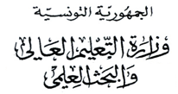
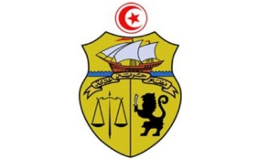
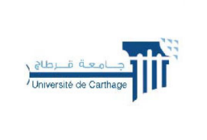

جامعة قرطاج
كلية العلوم الاقتصادية والتصرف بنابل

LISTE DES ETUDIANTS ORIENTES
2EB
N | CIN / Passport | Nom | Prénom
1 | *****447 | Mzoughi | Imen
2 | *****070 | israa | mezrani
3 | *****284 | Mallat | Manar
4 | *****015 | TCHEUDJOU | NESTOR WILFRIED
5 | *****247 | sahnoun | ghofrane
6 | *****018 | Nchouwat Fit | Fadil
7 | *****058 | Eya | Lassoued
8 | *****709 | saidi | al moataz billah
9 | *****943 | Dridi | Ichrak
10 | *****195 | MEDINI | KOUSSAY
11 | *****396 | DHIFALLAH | AMER
12 | *****669 | DABOUSSI | YOUSSEF
13 | *****656 | GHARBI | AHMED HOUSSEMEDDIN
14 | *****176 | GORAB | MOHAMED AMINE
15 | *****412 | KHEMIR | AMEN ALLAH
16 | *****861 | BELHAJ ALI | MOHAMED
17 | *****402 | SASSI | MOHAMED ACHOUR
18 | *****024 | HAMRAOUI | SARRA

