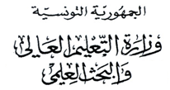
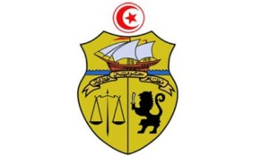


جامعة قرطاج
كلية العلوم الاقتصادية والتصرف بنابل

LISTE DES ETUDIANTS ORIENTES
3 management
N | CIN / Passport | Nom | Prénom
1 | *****638 | BEN KHALFALLAH | MENYAR
2 | *****359 | DHOUIBI | KHALED
3 | *****662 | HEDHILI | NOUR
4 | *****194 | CHAMEKH | AMENI
5 | *****234 | NAOUARA | YASMINE
6 | *****018 | CHERIF | DOUAA
7 | *****030 | REDJEL | AMIRA NARIMANE
8 | *****174 | ZANNED | GHOFRANE
9 | *****128 | NEMLAGHI | ALIA
10 | *****601 | FENNANI | IDRIS
11 | *****354 | ZAYATI | RAYAN
12 | *****372 | TORJMEN | SYRINE
13 | *****268 | Mansouri | Yosr
14 | *****294 | BOUALI | OMAR
15 | *****150 | LOUATI | TAKWA
16 | *****717 | BELLAR | AMENI
17 | *****244 | GHARBI | MANEL
18 | *****743 | EL FEHEM | SIRINE
19 | *****191 | ABBES | SIWAR
20 | *****550 | HMAIDI | EYA
21 | *****852 | YOUNES | AYMEN
22 | *****809 | JLASSI | CHAHINE
23 | *****481 | Mestouri | Mohamed Dhia
24 | *****247 | HADDAD | YOUSSEF
25 | *****162 | GATRI | WISSAL
26 | *****591 | FATHALLAH | NOUR ISLEM
27 | *****942 | FERJENI | MOHAMED

