
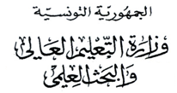
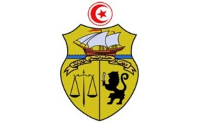

جامعة قرطاج
كلية العلوم الاقتصادية والتصرف بنابل

LISTE DES ETUDIANTS ORIENTES
3ape
N° | CIN / Passport | Nom | Prénom
1 | *****355 | jlassi | mohamed
2 | *****929 | Ben daoud | Nada
3 | *****371 | Abed | Amal
4 | *****647 | Abbassi | Meniar
5 | *****317 | Chatti | Syrine
6 | *****700 | Nabi | Chadha el ward
7 | *****731 | Ben arbia | Fatma
8 | *****686 | Dguechi | Balkiss
9 | *****400 | Bouchkati | Oumaima
10 | *****264 | Ghofrane | Chaieb
11 | *****086 | Ben sidhom | Molka
12 | *****189 | khamassi | hadir
13 | *****289 | Mrabti | Wijdene
14 | *****726 | islem | Mabrouk
15 | *****235 | Bouafif | Zakia
16 | *****665 | Assili | Emna
17 | *****294 | Dridi | Hyba
18 | *****534 | Naili | lenda
19 | *****901 | Benkedim | Rafeh
20 | *****241 | Bilel | Hajali
21 | *****350 | Naziha | Chourabi
22 | *****126 | Ghazouani | Nada
23 | *****695 | yassmine | hassad

