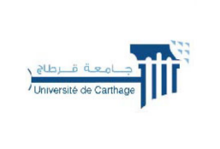
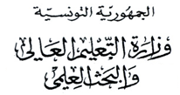
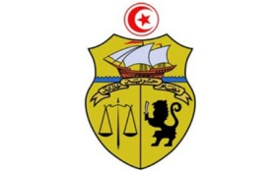

جامعة قرطاج
كلية العلوم الاقتصادية والتصرف بنابل

LISTE DES ETUDIANTS ORIENTES
3CFI
N° | CIN / Passport | Nom | Prénom
1 | *****888 | jedidi | firas
2 | *****027 | Wala | Hammami
3 | *****519 | Emna | Harrathi
4 | *****141 | Souissi | Malek
5 | *****430 | Dougha | Linda
6 | *****314 | Hichri | Amine
7 | *****537 | Mrah | Oussema
8 | *****256 | Jbir | Siwar
9 | *****765 | Hedyl | Baccouche
10 | *****748 | Nourhene | Essid
11 | *****210 | Loumerem | Malak
12 | *****993 | Hana | Oueslety
13 | *****795 | Hamraoui | Mohamed
14 | *****307 | barhoumi | rimeh
15 | *****166 | Fedi | Khemir
16 | *****731 | Khedhri | Chayma
17 | *****564 | Abdrahim | Marouki
18 | *****096 | taher | aymen
19 | *****196 | Ben hjal | Chedhly
20 | *****366 | gharbi | mariem
21 | *****921 | ines | betayeb
22 | *****945 | Sliti | Sarra
23 | *****380 | Essid | Yasmine
24 | *****770 | Sebai | Fourat
25 | *****826 | Gharbi | Ayoub
26 | *****169 | Ayari | Saif
27 | *****736 | Raboudi | Meriem
28 | *****008 | Mabrouki | Mohamed aziz
29 | *****455 | Azouz | Eya
30 | *****054 | Boughdiri | Nermin

