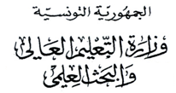
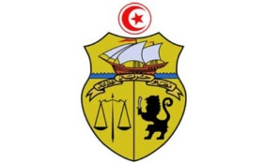
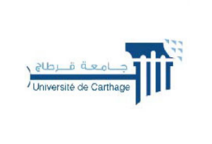

جامعة قرطاج
كلية العلوم الاقتصادية والتصرف بنابل

LISTE DES ETUDIANTS ORIENTES
3MFBA
N | CIN / Passport | Nom | Prénom
1 | *****825 | Gabsi | Molka
2 | *****711 | Cherni | Wala
3 | *****184 | WALA | SGHAIRI
4 | *****943 | Ajili | Amal
5 | *****846 | Hammami | Ghaith
6 | *****768 | Mangour | Hadir
7 | *****134 | Mechergui | Abla
8 | *****939 | Hafsouni | Chirine
9 | *****766 | Nafti | Maryem
10 | *****942 | Arij | Gadoudi
11 | *****824 | Ben haj mouldi | Haifa
12 | *****838 | Haifa | Fathallah
13 | *****475 | Arbi | Moutia
14 | *****367 | jlassi | tayssir
15 | *****951 | Mejri | Nourchen
16 | *****977 | Issaoui | Abed melek
17 | *****092 | Chhibi | Imen
18 | *****864 | Khammar | Maram
19 | *****104 | Bouzayene | Feryel
20 | *****870 | May | Rania
21 | *****433 | Jelloul | Seif eddine
22 | *****041 | Nada | Jemai
23 | *****691 | Hedhli | Jihen
24 | *****100 | Lachkam | Mayssa
25 | *****138 | Ben chahla | Abir
26 | *****110 | Ben amara | Nermine
27 | *****648 | El kateb | Nourchaine
28 | *****938 | Skendaji | Ameni
29 | *****972 | ones | Ben rhouma
30 | *****532 | el adel | Israa
31 | *****371 | Achour | Hadil
32 | *****124 | Amal | Awadi
33 | *****905 | Trabelssi | Nahed
34 | *****278 | Khadher | Ranim
35 | *****865 | Cherni | Insaf
36 | *****443 | Hiba allah | Osmen
37 | *****350 | Diouri | Eya
38 | *****243 | Sliti | Nedra
39 | *****390 | Abidi | Islem
40 | *****664 | Mnasri | Chaima
41 | *****262 | Ammar | Hend
42 | *****952 | Solaani | Yassmine
43 | *****449 | Ben ali | Amal
44 | *****070 | Ibtissem | Khantouch
45 | *****897 | Samoud | Riam
46 | *****369 | Khlify | Fatma
47 | *****028 | Salwa | Ferchichi
48 | *****707 | Dridi | Yomna
49 | *****823 | Beji | Soulaima
50 | *****914 | Ziadi | Nadhem
51 | *****469 | Belhadj | Nour
52 | *****635 | Nour El houda | Belkhamssa
53 | *****657 | Nourchene | Majdoub
54 | *****438 | Lahami | Mariem
55 | *****605 | Maryem | Bougatfa
56 | *****334 | Bessi | Yasmine
57 | *****636 | Ramez | Ben saoud
58 | *****628 | wuiem | riahi
59 | *****061 | Ghada | Ben jazia
60 | *****153 | Chaima | Barrani
61 | *****200 | Moudhi | Ghada
62 | *****727 | Ghrairi | Islem
63 | *****393 | hajjeji | jihen
64 | *****751 | Ghodhbani | Majdouline
65 | *****289 | Mzoughi | Aziza
66 | *****823 | Boudhawia | Hosni
67 | *****020 | Boudourou | Nour el islem
68 | *****177 | Nfaidh | Yasmine
69 | *****100 | Aloui | Amira
70 | *****534 | Najjar | Fatma
71 | *****528 | Daoud | Malek
72 | *****610 | Rayen | Hemdani
73 | *****036 | Zehiri | Syrine
74 | *****398 | Jilani | Hchaichi
75 | *****664 | Frikhi | Oumaya

